Step 2: open the CMD.exe prompt

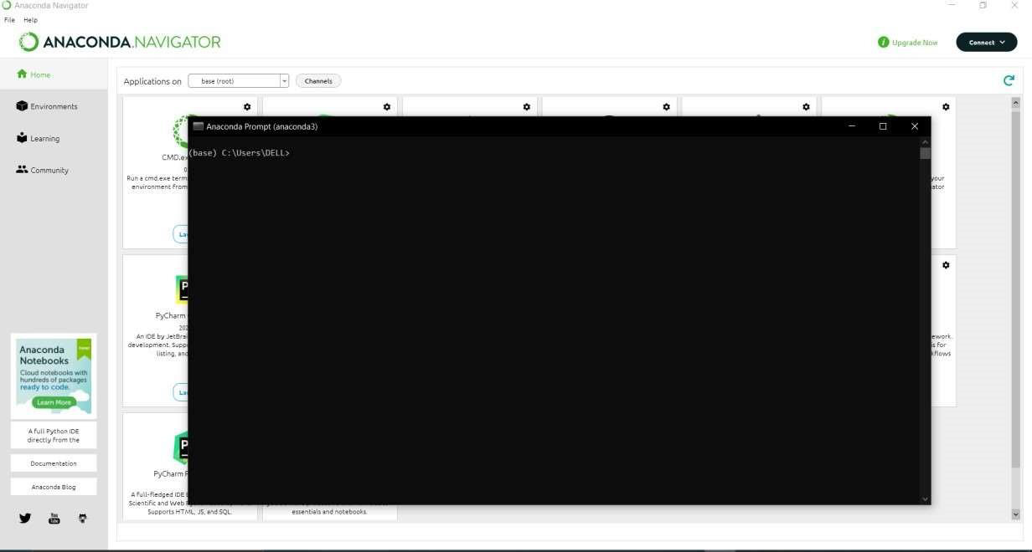

**Step 3: install the NUMPY package** .

To enter the numpy package enter the command in the CMD.exe Command:Pip install numpy

NUMPY :

Numpy: This package is used to perform numerical computations. This package is pre-installed

in anaconda.NumPy is used for working with arrays. NumPy is short for "Numerical Python

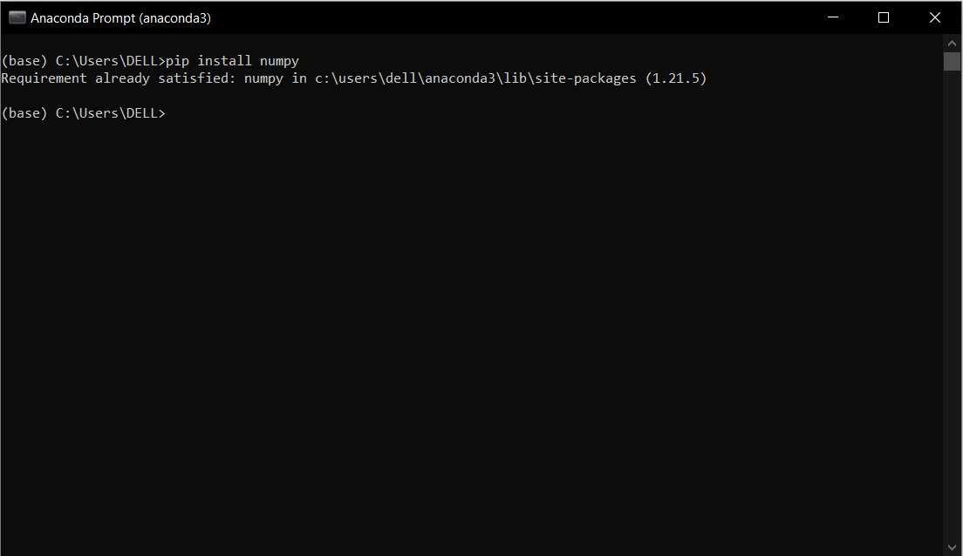

**Step 4: install the pandas package** .

To enter the pandas package enter the command in the CMD.exe Command: Pip install pandas

Pandas :

Pandas is one of the most widely used python

libraries in data science. It provides high-performance, easy to use structures, and data analysis

tools. This package is pre- installed in anaconda. is an open-source library that is built on top of

NumPy library. It is a Python package that offers various data structures and operations for

manipulating numerical data and time series. It is mainly popular for importing and analyzing

data much easier. Pandas is fast and it has high- performance & productivity for users

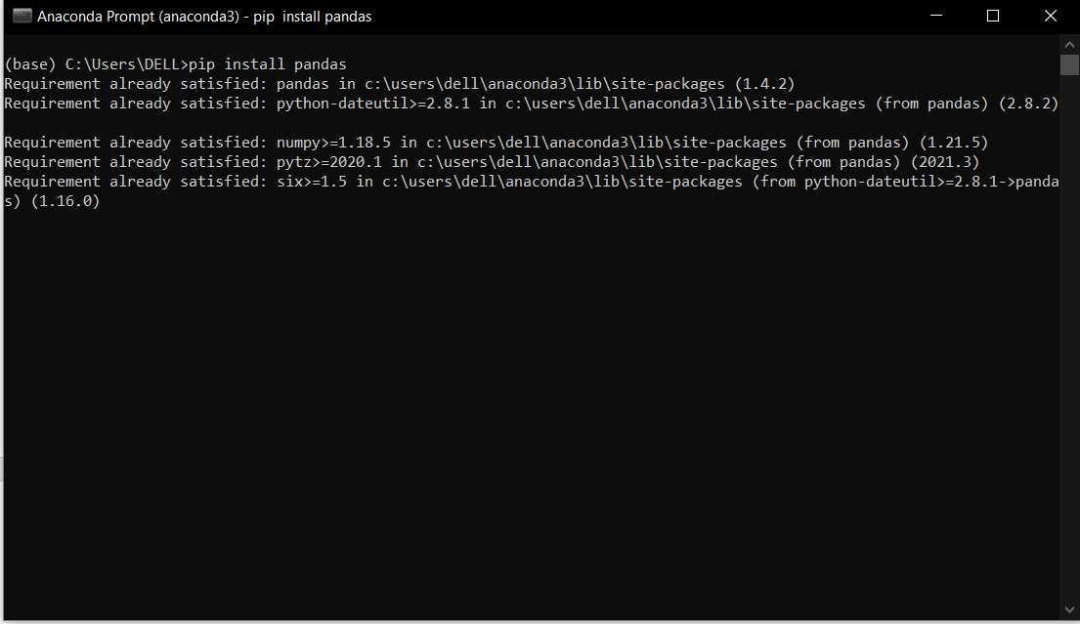

**Step 5: install the Matplotlib package** .

To enter the Matplotlib package enter the command in the CMD.exe Command: Pip install

Matplotlib Matplotlib :

Matplotlib is a comprehensive library for creating static, animated, and interactive visualizations

in Python. This package is pre-installed in anaconda .Matplotlib is an amazing visualization

library in Python for 2D plots of arrays. Matplotlib is a multi-platform data visualization library

built on NumPy arrays and designed to work with the broader SciPy stack. It was introduced by

John Hunter in the year 2022

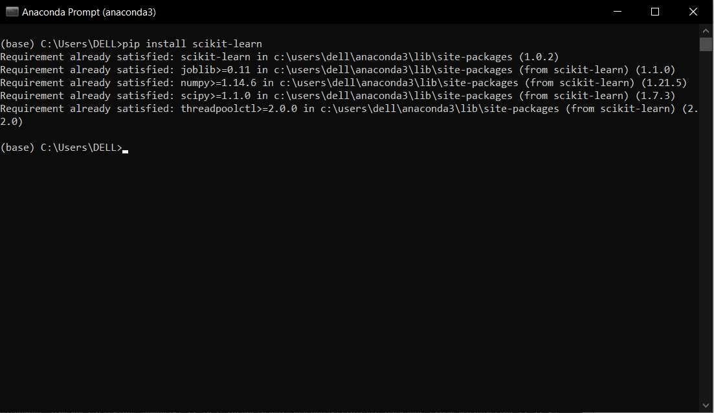

**Step 7: install the Flask package** .

to enter the Flask package enter the command in the CMD,exe Command: Pip install Flask

Flask :

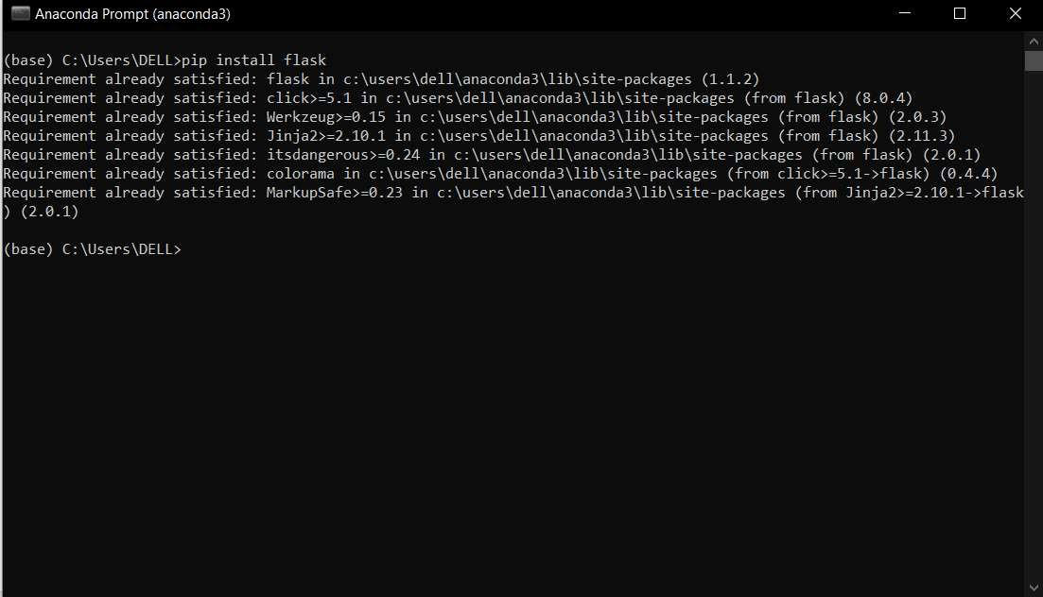

Flask is a lightweight WSGI web application framework Flask is a web application framework

written in Python. Armin Ronacher, who leads an international group of Python enthusiasts

named Pocco, develops it. Flask is based on Werkzeug WSGI toolkit and Jinja2 template

engine. Both are Pocco projects.